Aston University – School of Computer Science and Digital Technologies
Steps for having a working local website running WAMP (MS-Windows, Apache, MySQL, and PHP)
OBS: don’t skip steps – do as recommended, otherwise, it might not work.

- Download and install WAMP
  - Site: https://www.wampserver.com/en/download-wampserver-64bits/
    - On [20/12/2024] install file was https://www.wampserver.com/en/download-wampserver-64bits/#wampserver-64-bits-php-5-6-25-php-7 (this might change)
      - Version WAMPSERVER 64 ITS (X64) 3.3.5 download the latest version
  - You might be informed to install “Add-ons”: https://wampserver.aviatechno.net/
    - Look for “Visual C++ Redistributable Packages” download “All VC Redistributable Packages (x86_x64)(32 & 64bits)” on All VC Redistributable Packages (x86_x64) (32 & 64bits)
    - Install this file!
  - Install WAMP on C:\ or other drive (eg, D:\) – on the root of your filesystem
- Execute WAMP (click Windows button, then search “WAMP” as this figure shows:
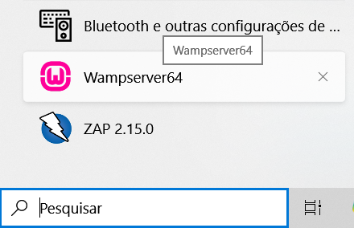
- This icon will be shown in your Systray: (green means all is working, red means problems)
- When you click on it, it shows:
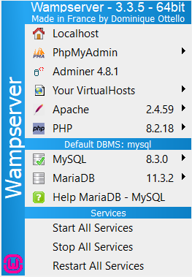
- We’ll use a simple application that creates tickets (ticketsystem) in a fictional Security Operations Centre (SOC).
  - Download https://ricardo.techster.uk/public/materials/ticketsystem.zip
  - Extract to C:\wamp64\www or D:\wamp64\www (depends WHERE you installed WAMP)
    - This is the usual folder to withhold your websites (I will install on D:\ my C:\ is full)
- Open file ticketsystem\queries.sql on a Text Editor (notepad or notepad++)
  - Observe that database “phpticket” will be created with two tables: tickets and tickets_comments
- Create database at PHPMyAdmin (using WAMP’s interface)
  - Go to http://localhost/phpmyadmin/
    - If you see an error, you have issues with your WAMP install – try to solve it
  - Everything working out, you’ll see this:
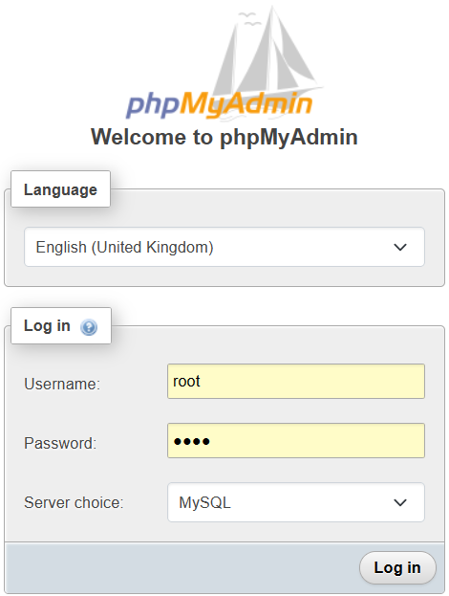
  - Unless you modified, user is root and password is root (try also “root” and empty password)
  - Click “SQL” or “Import” (both methods work)
    - If you chose “SQL”, copy paste contents of “queries.sql” into the textarea and hit “Go”
    - If you chose “Import” select file “queries.sql” on the file dialog “File to Import” and click “Import”
  - Everything working out without errors, you’ll see the created database on the left-hand side
    - Click on it, then inspect its tables, and fields (“Columns”)
- Now it’s time to create the Apache (WebServer) instance for the ticketsystem application
  - Go to WAMP (Systray) > Apache > Alias directories > “Add an alias”
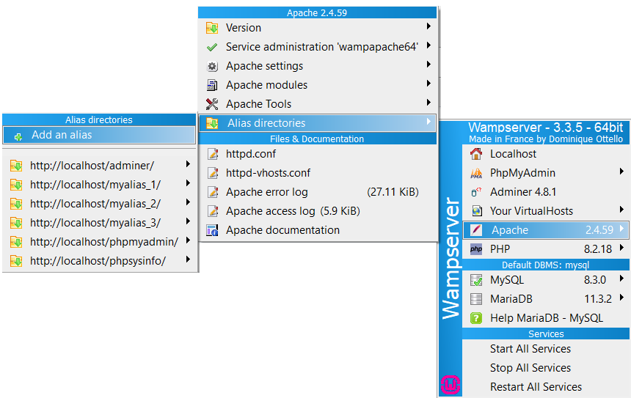
  - You shall see this:
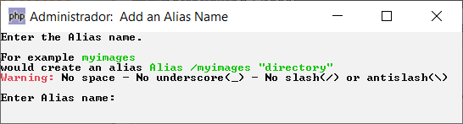
    - Put “ticketsystem” and hit <RETURN>
  - In “Enter your alias path:” put D:/wamp64/www/ticketsystem and hit <RETURN>
    - NOTE the use of a slash (“/”) instead of a backslash (“\”) this is important
    - Adjust your path, ie, if you installed WAMP on C:\ make the appropriate changes
  - You will see this:
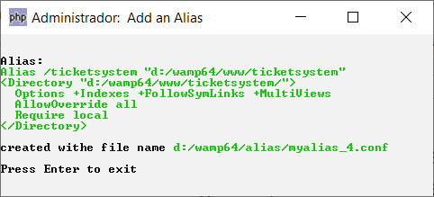
  - It means that everything went well
- Point your browser to http://localhost/ticketsystem/ (not HTTPS! It should be HTTP)
  - You shall see this:
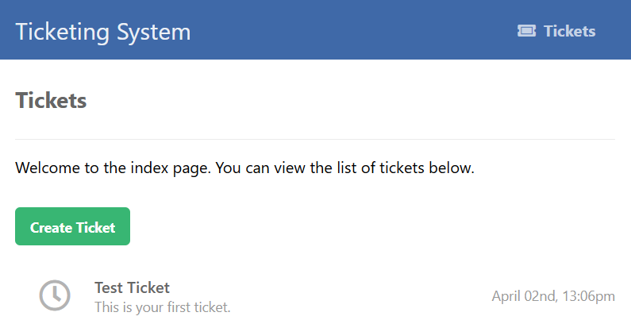
  - If you look at the data in the database, it corresponds to the one ticket that was created by the script (you can supress that if you want, just comment the lines with the INSERT command (“-- " comments in SQL are -- followed by a space – otherwise it doesn’t work!)
- That’s it! You have a working application on your machine!
  - Now, you can EXPAND it all, adding features, increasing the database with more tables, columns, etc.
  - Look at all PHP files in the folder and UNDERSTAND how they work.

If there are issues, well, try to look on the Internet for specific errors and suggestions.
Remember to SHUT-DOWN WAMP server whenever you’re not using it – it might expose your computer to the internet.

Best of luck!

